**Food Recognition App**

Submitted in partial fulfilment of the requirements

of the syllabus of

Android Apps Development Lab

in

Information Technology

by

AAYUSH PARAB 118A3002

ASHWIN NAIR 118A3031

ASHWATH NAMBIAR 118A3033

Under the Guidance of:

Ms. Bushra Shaikh



Department of Information Technology

SIES Graduate School of Technology

2021-22

**CERTIFICATE**

This is to certify that the project entitled **“**Food Recognition App**”** is a bonafide work of the following students, submitted to the University of Mumbai in partial fulfillment of the requirement of the syllabus of **Android Apps Development Lab** in **Information Technology.**

**AAYUSH PARAB 118A3002**

**ASHWIN NAIR 118A3031**

**ASHWATH NAMBIAR 118A3033**

Ms. Bushra Shaikh Dr. Lakshmi Sudha Dr. Atul N Kemkar

Internal Guide Head of Department Principal

**PROJECT REPORT APPROVAL**

This project report entitled ***Food Recognition App*** by following students is approved for the requirement of the syllabus of ***Android Apps Development Lab*** in ***Information Technology.***

**AAYUSH PARAB 118A3002**

**ASHWIN NAIR 118A3031**

**ASHWATH NAMBIAR 118A3033**

**Name of External Examiner: --------------------------------**

**Signature:--------------------------------**

**Name of Internal Examiner: --------------------------------**

**Signature:--------------------------------**

**Date:**

**Place:**

**DECLARATION**

I declare that this written submission represents my ideas in my own words and where others’ ideas or words have been included, I have adequately cited and referenced the original sources. I also declare that I have adhered to all principles of academic honesty and integrity and have not misrepresented or fabricated or falsified any idea/data/fact/source in my submission. I understand that any violation of the above will be cause for disciplinary action by the Institute and can also evoke penal action from the sources which have thus not been properly cited or from whom proper permission has not been taken when needed.

AAYUSH PARAB 118A3002 _____________

ASHWIN NAIR 118A3031 _____________

ASHWATH NAMBIAR 118A3033 _____________

Signature

Date:

**ACKNOWLEDGEMENT**

It gives us immense pleasure to thank Dr. Atul N Kemkar, our Principal for extending his support to carry out and develop the project. We also thank our Head of Department Dr. Lakshmi Sudha for her support in completing the project. We wish to express our deep sense of gratitude and thank our Internal Guide, Ms. Bushra Shaikh for her guidance, help and useful suggestions, which helped in completing our project work in time.

We would like to thank the entire faculty of the Information Technology Department for their valuable ideas and timely assistance in this project. Last but not least, we would like to thank our non-teaching staff members of our college for their support, in facilitating timely completion of this project.

**Project Team**

AAYUSH PARAB

ASHWIN NAIR

ASHWATH NAMBIAR

**ABSTRACT**

One of the emergent concerns of human life is about health and wellness. Undeniably, health and nutrition are one of the valuable aspects of life. Thus, technological innovations to help enhance and even promote health awareness is essential. With the advent of mobile computing, it is much easier to be aware of health information because of its mobility and availability. Many mobile applications are being developed to serve as a tool for health monitoring and nutritional guidance. Mobile applications have the ability to support health needs like detecting heart rate, classifying food, and many more. Taking advantage of technology, utilization of it hereby addresses certain issues and problems of human life, especially in health. In this study, the researcher attempts to design and develop an Android-based food recognition application that could be used as a health awareness tool for non-health conscious individuals. The application lets the user take the photo of the food and show its nutritional contents. Implementing Mifflin-St Jeor method in determining daily calorie consumption, users shall be aware of their required calorie intake. Moreover, the researchers' have studied its effect on people's health awareness on food nutrition by the randomly selected respondents. Finally, this paper presents an analysis of the impact of the food recognition app to change people's concept of food nutrition.

**Contents**

|  |  |  |
| --- | --- | --- |
|  |  | **Page No.** |
| **Chapter 1** | **Introduction** | **8** |
| **Chapter 2** | **Survey of Existing Apps** | **9** |
| **Chapter 3** | **Report on Present Investigation** | **10** |
|  | 3.1 Problem Statement | **10** |
|  | 3.2 Source of Problem Statement | **10** |
| **Chapter 4** | **Design and Implementation of Android Apps Components** | **11-14** |
|  | 4.1 Layouts | **11** |
|  | 4.2 Intents | **11** |
|  | 4.3 Activity | **12** |
|  | 4.4 SQLite | **12** |
|  | 4.5 Camera | **12** |
|  | 4.6 Multimedia | **13** |
|  | 4.7 Location API | **13** |
|  | 4.8 Generate APK file | **13-14** |
| **Chapter 5** | **Report on Proposed System and its Implementation** | **15-17** |
|  | 5.1 Block Diagram | **15-16** |
|  | 5.2 Flowchart | **16** |
|  | 5.3 Hardware | **17** |
| **Chapter 6** | **Results and Discussions** | **18-19** |
|  | 6.1 Summary of Screenshots with Navigational Flow |  |
| **Chapter 7** | **Conclusions** | **20** |
|  | **References** | **21** |

**Introduction**

Food plays a key role in human life and even in the global economy. There is a strong correlation between eating choices and people's culture, economic situation, and health status (Nishida, Uauy, Kumanyika, & Shetty [2004](https://www.ncbi.nlm.nih.gov/pmc/articles/PMC7859960/#ref80)). Some unhealthy eating is done with intent, for various reasons, but some of it is simply thoughtless. People would often make a healthier choice if they thought about it and be happy about doing so. They know what is healthier if asked and are not necessarily averse to choosing it. But they do not habitually engage in the assessment necessary to make that choice. Calling their attention to their dietary choices, without any attempt at persuasion or even provision of new information, can be enough to improve health and welfare (Nishida *et al.*, [2004](https://www.ncbi.nlm.nih.gov/pmc/articles/PMC7859960/#ref80); Suthumchai *et al.*, [2016](https://www.ncbi.nlm.nih.gov/pmc/articles/PMC7859960/#ref108)). Bad eating habits are one of the main cause of many chronic diseases such as: obesity, diabetes, dental diseases, cancer, osteoporosis and cardiovascular ones (Nishida *et al.*, [2004](https://www.ncbi.nlm.nih.gov/pmc/articles/PMC7859960/#ref80); Suthumchai, Thongsukh, Yusuksataporn, & Tangsripairoj [2016](https://www.ncbi.nlm.nih.gov/pmc/articles/PMC7859960/#ref108)), which may affect the financial status of a country, because of the direct medical costs, productivity costs and also human capital cost (Hammond & Levine, [2010](https://www.ncbi.nlm.nih.gov/pmc/articles/PMC7859960/#ref42)); in 2002, a Joint WHO/FAO (World Health Organization /Food and Agriculture Organization) Expert Consultation has proved the growing epidemic of chronic disease which affect most of the countries in the world is caused to dietary and lifestyle changes. Even though minimum life standards have improved, the rise of food availability and the higher diversification, have led to serious negative consequences in terms of multiple aspects: unhealthy dietary habits; decrease of physical activities; increase in food-related chronic diseases. In 2001, chronic diseases contributed to about 60% of the 56.5 million reported deaths in the world and 46% of the global disease. It has been estimated, this percentage is going to increase to 57% by 2020. Moreover, cardiovascular problems are the cause of about half of the total chronic disease deaths. Another alarming trend is that obesity and diabetes have even started to appear earlier in people’s life. In most of the countries of the WHO, deaths caused by chronic diseases dominate the mortality statistics (Nishida *et al.*, [2004](https://www.ncbi.nlm.nih.gov/pmc/articles/PMC7859960/#ref80)) and led the governments to interest on food and nutrition policy, health promotion, and strategies for the control and prevention of chronic diseases.

Recognizing food from images is an extremely useful tool for a variety of use cases. In particular, it would allow people to track their food intake by simply taking a picture of what they consume. Food tracking can be of personal interest, and can often be of medical relevance as well. Medical studies have for some time been interested in the food intake of study participants but had to rely on food frequency questionnaires that are known to be imprecise.

Image-based food recognition has in the past few years made substantial progress thanks to advances in deep learning. But food recognition remains a difficult problem for a variety of reasons.

**Survey On Existing Apps**

**1. Calorie Mama**

One of the most pressing problems in modern life is one's health and well-being. Without a doubt, one of the most valuable parts of life is one's health and nutrition. As a result, technology advancements that can help improve and even increase health awareness are critical. Because of its mobility and accessibility, mobile computing has made it much easier to be aware of health information. Many mobile applications are being created to act as health monitoring and nutritional guidance tools. Mobile applications can help with things like heart rate detection, food classification, and much more. Taking use of technology and putting it to good use tackles a number of issues and concerns.

**Report on Present Investigation**

**3.1) Problem Statement:**

We focused on multiple aspects that contribute to building a mobile e-health application that would provide tools to monitor calorie intake and assist users to ensure a healthy diet. The system is able to recognize the food object on the user’s plate and determine its calorie content. We will further discuss some of the problems with the existing approaches below. The patient’s dietary information helps doctors gain the information they need to diagnose problems, such as obesity- and weight-related issues. In the existing approach, patients report their daily diet to a dietician. The problem with this approach is that it provides an inaccurate measure of the sizes of food portions, which neglects the fundamental reason for inconsistencies in calorie calculation while maintaining dietary information. One challenge of calorie computation is the ability to gauge the quantity of the real object in a two-dimensional image. Existing approaches require a reference object, such as a finger, coin, or scale, to calibrate the food dimensions. The problem with this approach is that it is cumbersome for the user to take a picture using a mobile phone while placing the reference object. If the dimensions of the reference object were recorded incorrectly, it would result in an inaccurate measurement of the dimensions of the food portion, thus further affecting the overall calorie value. Another problem in computing calorie intake is that the quantity of the food object, which contributes to its overall calorie content, changes according to the position of the mobile device with respect to the food object. The user’s distance from the food object 4 also directly affects the size ratio of the food object. In other words, the farther the user stands from the food object, the smaller it appears in the captured image, and the lower number of calories that are computed. However, distance measurement methods, which are critical in determining the dimensions of the food object, have not yet been proposed, and the existing approaches do not address this challenge in computing calories. Furthermore, existing approaches compute the dimensions of the food portions by splitting them into blocks and then calculating the area of the individual blocks. However, in this approach, the problem is that the block size remains the same, irrespective of the distance from which the images are captured. This leads to the inaccurate measurement of the food portion size and to a higher ration of errors in the number of calories consumed. Hence, there is the need for an approach that uses the distance measurement method to determine the units of the blocks. Currently, many computer vision algorithms are available for image recognition and face recognition, which are used to determine the class of the object by analyzing a two dimensional image. However, the results of studies on deep learning have proved to be significantly more accurate in classifying these images. Therefore, an approach that uses deep learning methodology to recognize food images is required because they have unique characteristics distinguishes them from other classes of generic images. The existing mobile e-health applications require frequent feedback and suggestions by the user for the system to classify accurately the food object and compute the calorie intake. In most applications, either the processing is too lengthy or frequent input from the user is required, such as the ingredients, the food category, or the unit 5 measurements required. Applications that require frequent user inputs are likely to make the user lose interest, thus undermining the entire user experience. Another problem associated with calorie computation is that the existing approaches follow the same methodology to address all food objects, which leads to inaccurate calculations of the number of calories. Each food class has unique characteristics that need to be considered when the total number of calories is calculated. Another challenge in current applications for food recognition and calorie computation is distinguishing multiple food objects or mixtures of food objects on the plate. In order to differentiate the total number of food objects in the plate, each food object is treated separately. In addition, all calories are summed and displayed to the user because the system was designed to work automatically. Current approaches do not address this concern in computing the number of calories.

**Design and Implementation of Android Apps Components**

**4.1) Layouts**

Layout basically refers to the arrangement of elements on a page; these elements are likely to be images, texts or styles. These are a part of **Android Jetpack**. They define the structure of [android user interface](http://web.cs.wpi.edu/~emmanuel/courses/cs4518/C17/slides/lecture03.pdf) in the app, like in an activity. All elements in the layout are built with the help of Views and ViewGroups. These layouts can have various widgets like buttons, labels, textboxes, and many others.

Some of the Layouts in Android are

* Linear Layout
* Relative Layout
* Constraint Layout
* Table Layout
* Frame Layout
* Absolute Layout

You can declare a layout in two ways:

* **Declare UI elements in XML**. Android provides a straightforward XML vocabulary that corresponds to the View classes and subclasses, such as those for widgets and layouts.

You can also use Android Studio's [Layout Editor](https://developer.android.com/studio/write/layout-editor) to build your XML layout using a drag-and-drop interface.

* **Instantiate layout elements at runtime**. Your app can create View and ViewGroup objects (and manipulate their properties) programmatically.

**We have used Relative Layout for the Login and registration page.**

**We have used Scroll view with LinearLayout for designing all the data structure and algorithm pages.**

**4.2) Intents**

**Android Intent** is the *message* that is passed between components such as activities, content providers, broadcast receivers, services etc.

It is generally used with the startActivity() method to invoke activity, broadcast receivers etc.

There are two types of intents:

* **Explicit intents** specify which application will satisfy the intent, by supplying either the target app's package name or a fully-qualified component class name. You'll typically use an explicit intent to start a component in your own app, because you know the class name of the activity or service you want to start. For example, you might start a new activity within your app in response to a user action, or start a service to download a file in the background.

**We have used Explicit intent to connect various activities like going to home page from login, and also for browsing the contents of data structures and algorithms.**

*Intent intSignUp = new Intent(SignIn.this, MainActivity.class);  
intSignUp.addFlags(Intent.FLAG_ACTIVITY_NEW_TASK | Intent.FLAG_ACTIVITY_CLEAR_TASK);  
startActivity(intSignUp);*

* **Implicit intents** do not name a specific component, but instead declare a general action to perform, which allows a component from another app to handle it. For example, if you want to show the user a location on a map, you can use an implicit intent to request that another capable app show a specified location on a map.

**We have used Implicit intent to allow users to choose a profile image from gallery, and also to select a location map.**

*Intent takePicture = new Intent(MediaStore.ACTION_IMAGE_CAPTURE);*

**4.3) Activity**

To navigate transitions between stages of the activity lifecycle, the Activity class provides a core set of six callbacks: onCreate(), onStart(), onResume(), onPause(), onStop(), and onDestroy(). The system invokes each of these callbacks as an activity enters a new state.

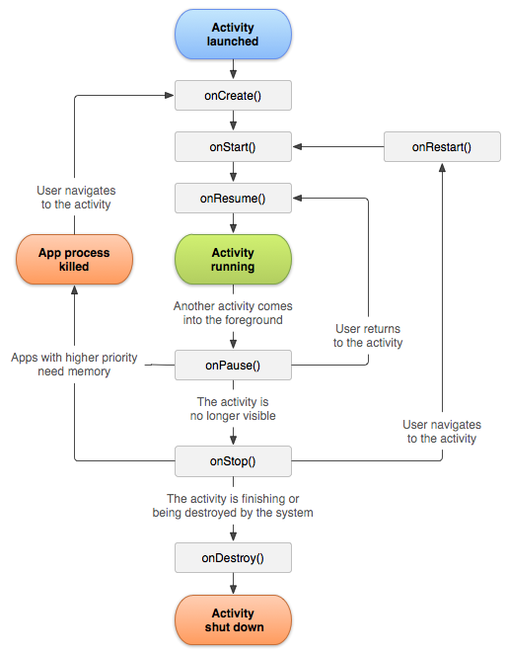

**Activities in our application are:**

**Login Page**

**Register Page**

**Splash screen**

**Main activity**

**Location page**

**Capture Image**

**Display Image**

**Prediction**

**4.4) Database**

SQLite is a C-language library that implements a [small](https://www.sqlite.org/footprint.html), [fast](https://www.sqlite.org/fasterthanfs.html), self contained, [high-reliability](https://www.sqlite.org/hirely.html), [full-featured](https://www.sqlite.org/fullsql.html), SQL database engine. SQLite is the [most used](https://www.sqlite.org/mostdeployed.html) database engine in the world. SQLite is built into all mobile phones and most computers and comes bundled inside countless other applications that people use every day.

The SQLite [file format](https://www.sqlite.org/fileformat2.html) is stable, cross-platform, and backwards compatible and the developers pledge to keep it that way [through the year 2050](https://www.sqlite.org/lts.html). SQLite database files are commonly used as containers to transfer rich content between systems and as a long-term archival format for data. There are over 1 trillion (1e12) SQLite databases in active use.

**We have used SQLite to store the user details entered at the time of registration. SQLite helps the app to retrieve the data entered at time of registration in the profile page.**

**4.5) Camera**

**Camera** is mainly used to capture picture and video. We can control the camera by using methods of camera api.

Android provides the facility to work on camera by 2 ways:

1. By Camera Intent
2. By Camera API

**We have used cameras to allow users to take a picture for the food image. We used the Camera Intent.**

*Intent takePicture = new Intent(MediaStore.ACTION_IMAGE_CAPTURE);*

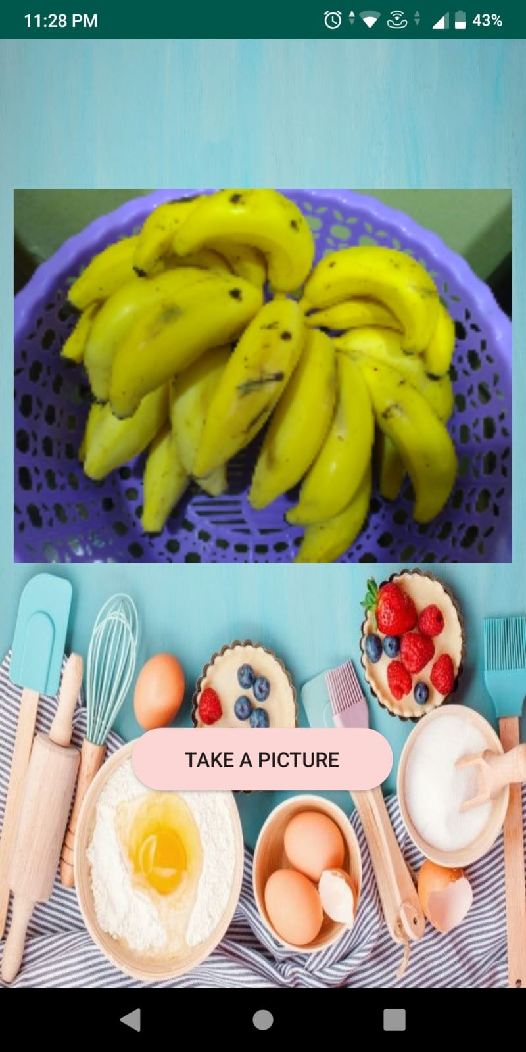

**4.6) Location API**

The location APIs available in Google Play services facilitate **adding location awareness to** your app with automated location tracking, wrong-side-of-the-street detection, geofencing, and activity recognition.

**We have used the location api to take the address of the user.**

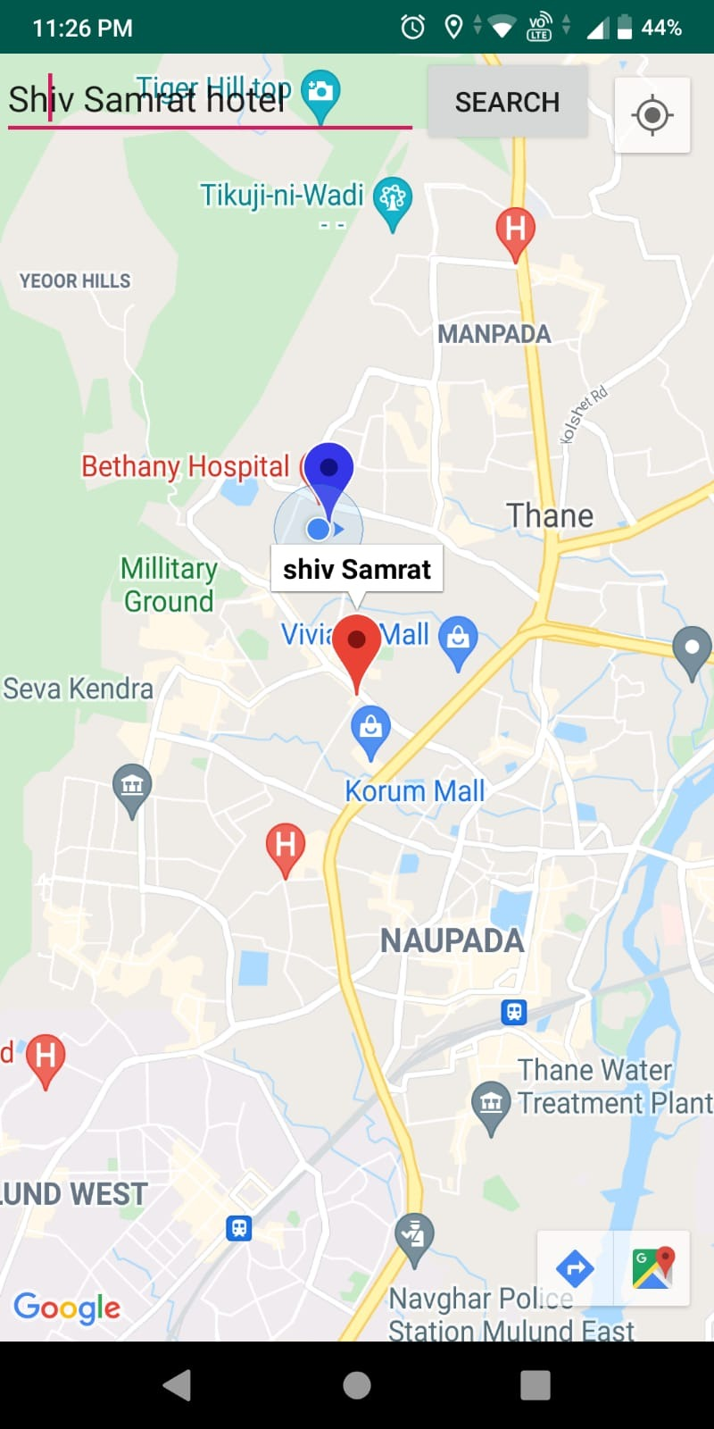

**4.8) Multimedia**

The Android multimedia framework includes support for playing variety of common media types, so that you can easily integrate audio, video and images into your applications

**We have made use of images for the step-by-step representation of examples.**

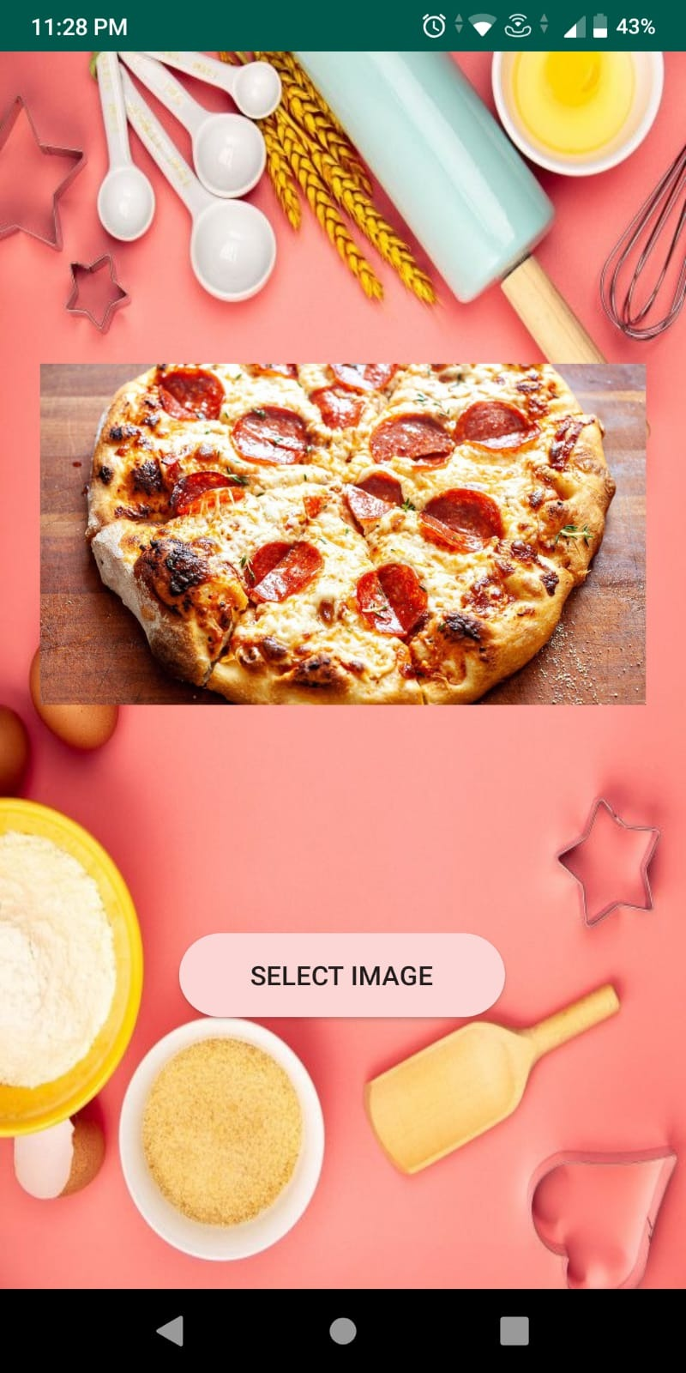

**Flowchart:**













































**Hardware –**

* Android Device
* GPS
* Camera

**Software / External Libraries used with description –**

* Android Studio

Android Studio provides a unified environment where you can build apps for Android phones, tablets, Android Wear, Android TV, and Android Auto. Structured code modules allow you to divide your project into units of functionality that you can independently build, test, and debug.

**Results and Discussions:**

**Screenshots of app-**

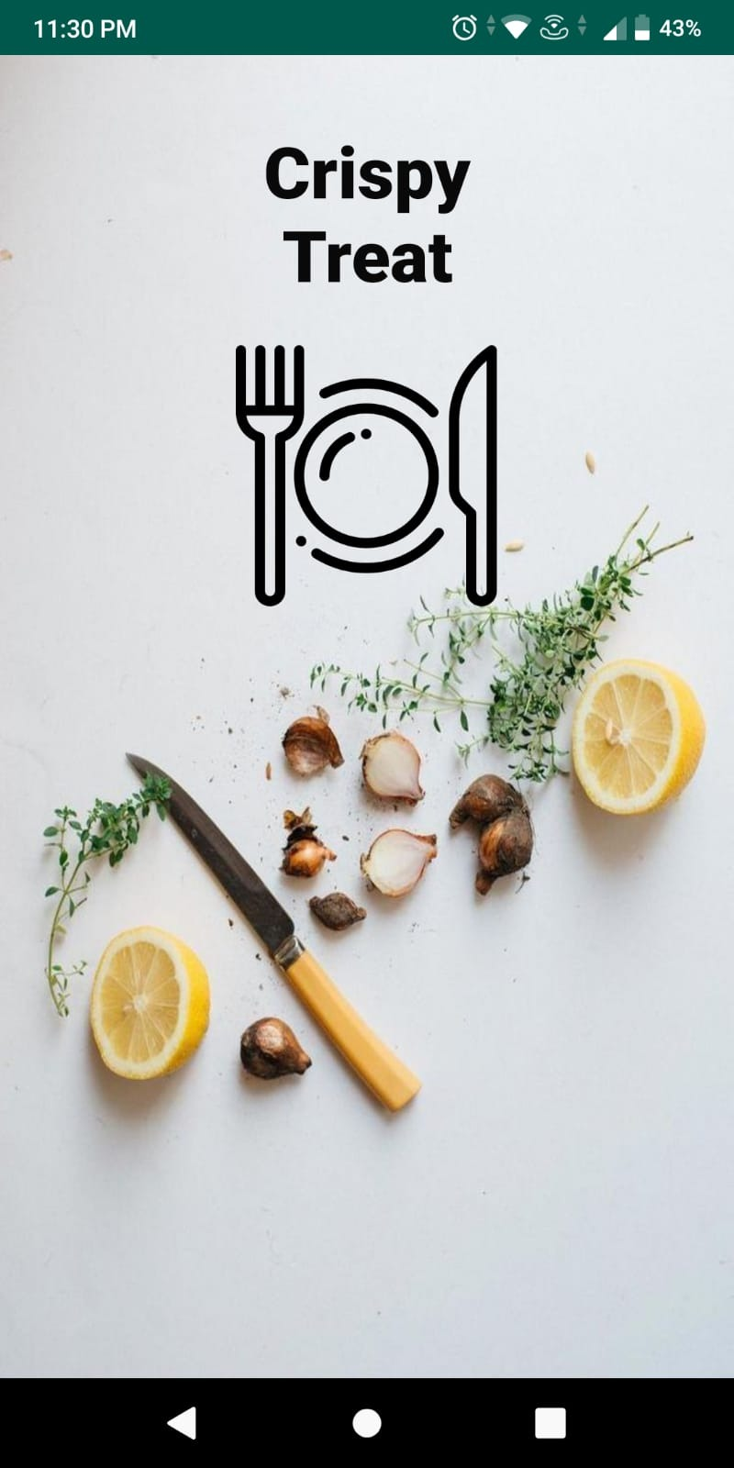 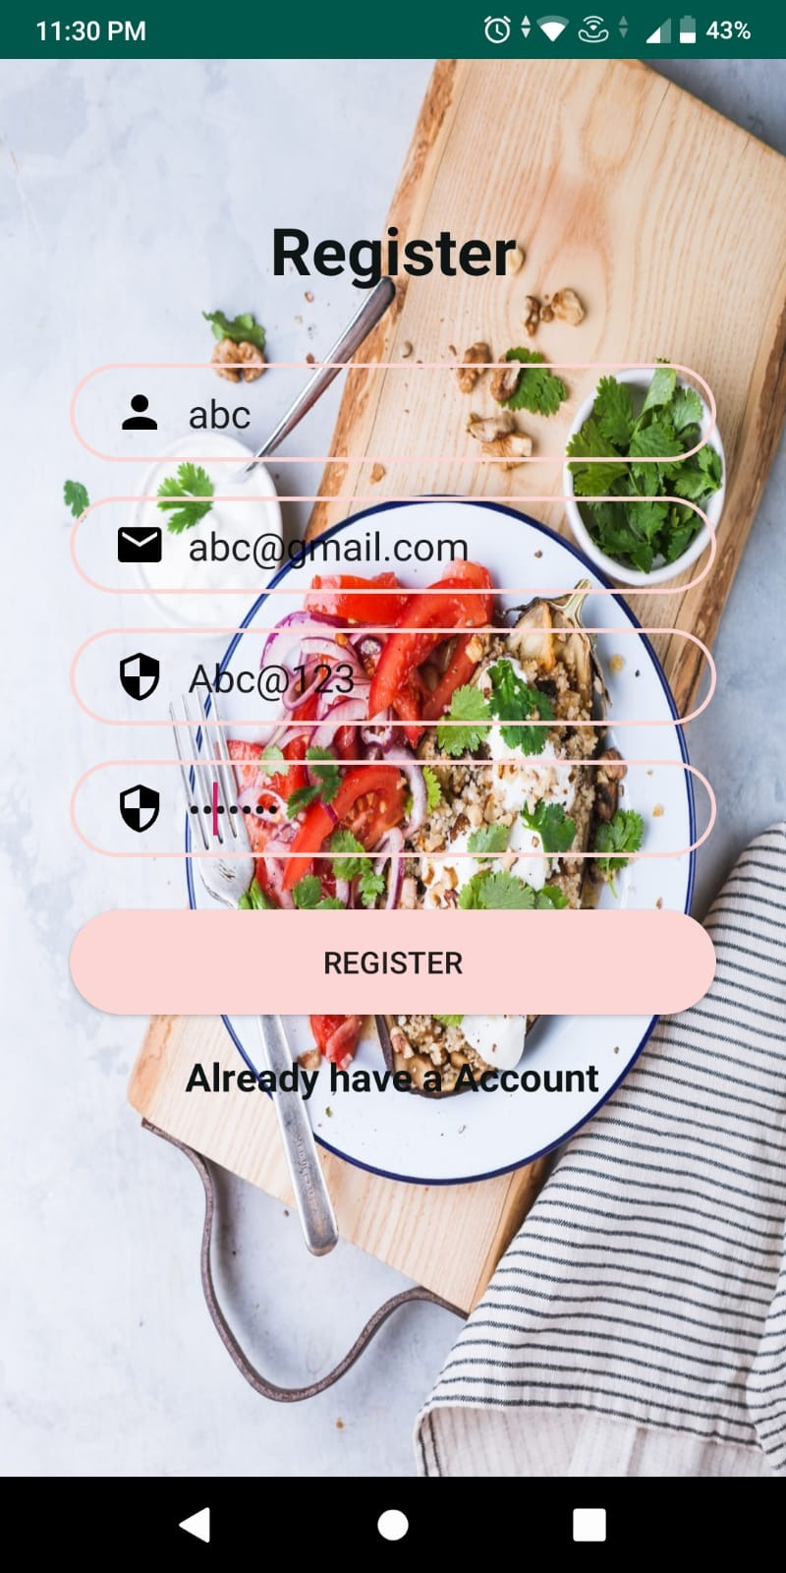

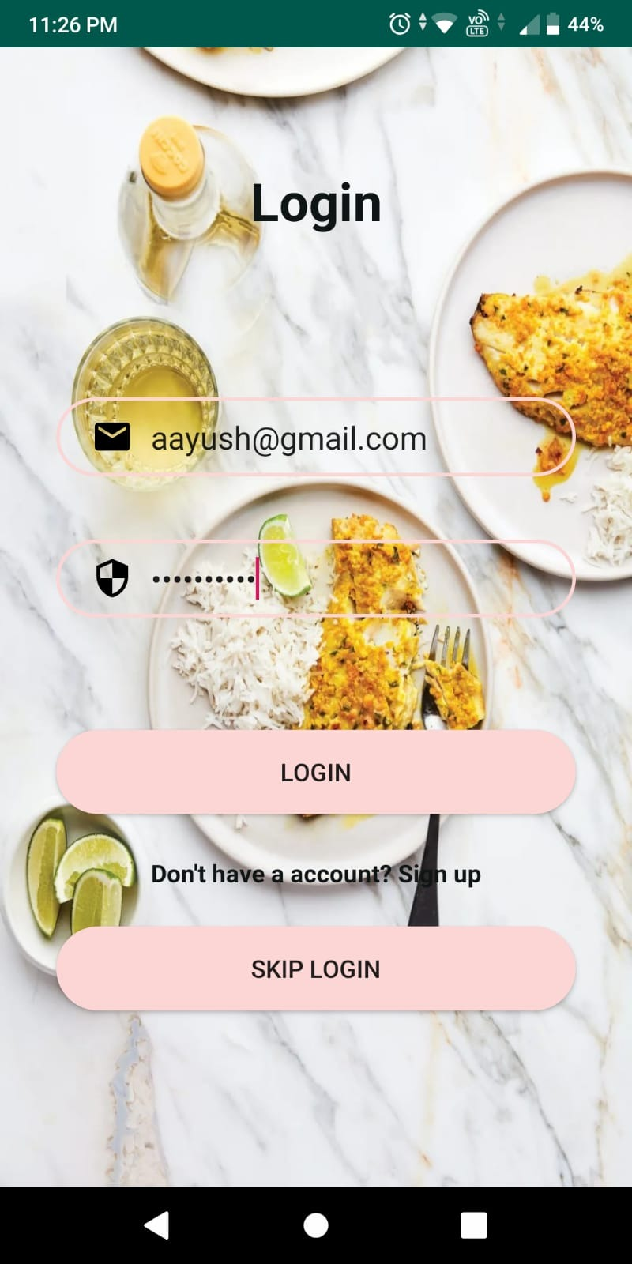 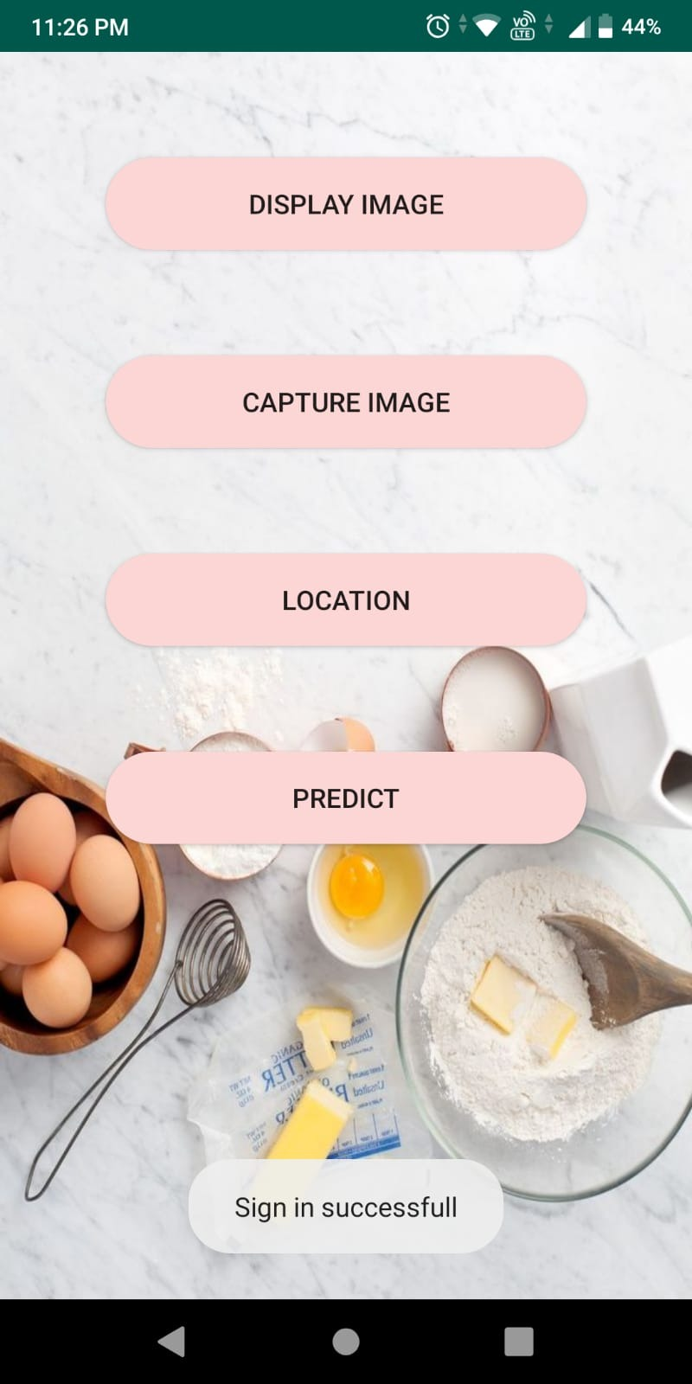

** **



**Conclusion**

Thus we have successfully built an android application that correctly identifies various food dishes and their following components are identified to their percentages.

We can make an account and login, upload and take photos, use location features and food identification features.

Future Scope:

Improving the model for food recognition and classification. We are thinking about trying a CNN model, which should improve the accuracy from our current model

**References**

1. Firebase authentication, setup, storage, google-sign in and notifications documentations.

[2] <https://youtu.be/nRvxjSfJEK8>

[3] <https://www.youtube.com/watch?v=u5PDdg1G4Q4>

[4] https://developers.google.com/maps/documentation/places/web-service/overview